**Sprint 1**

Date TEAM ID

Project Name

24 October 2022

PNT2022TMID30395

IoT Based smart crop Protection system for agriculture

Maximum mark 20 marks

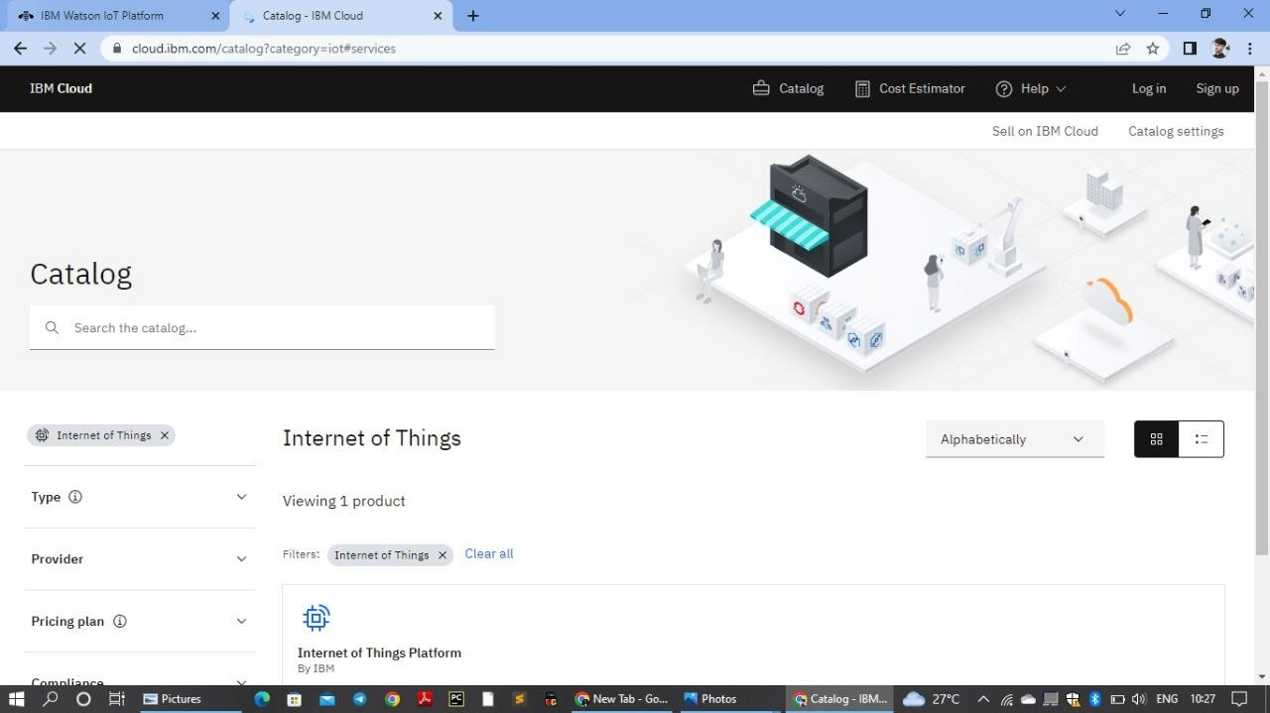

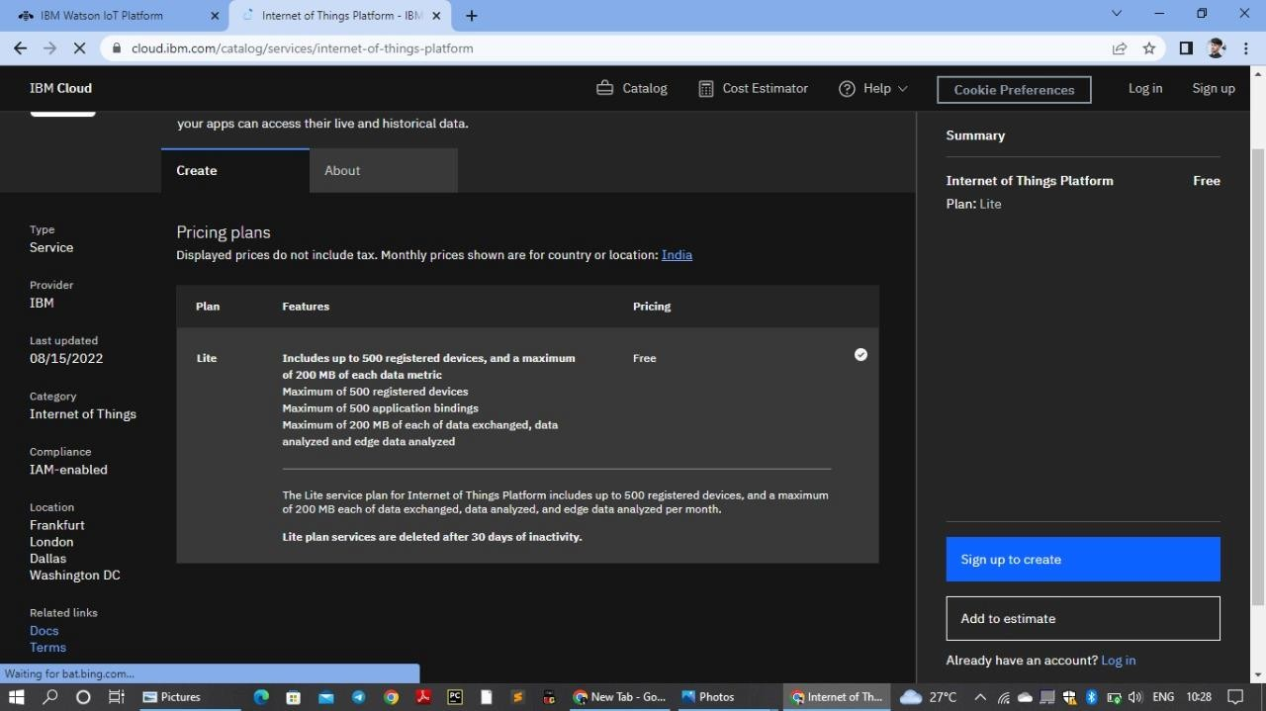

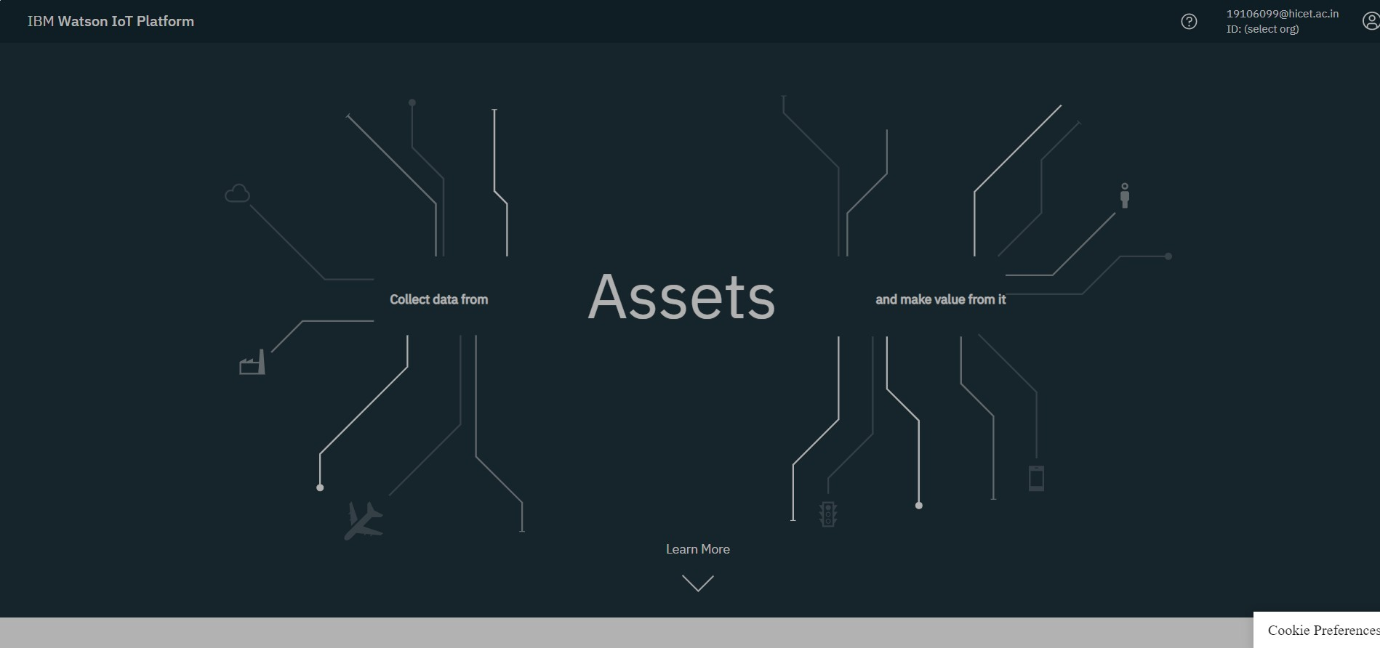

**Device Drilldown - PNT2022TMID30395**

**Device credentials**

|  |  |
| --- | --- |
| **Organization ID** |  |
| **Device type** | **PNT2022TMID30395** |
| **Device ID** | **PNT2022TMID30395** |
| **Authentication Method** | **Use token auth** |
| **Authentication Table** | **3kZiAwQMTL?4111nj3** |

|  |  |
| --- | --- |
| **Device ID** | **PNT2022TIMD30395** |
| **Device Type** | **PNT2022TIMD30395** |
| **Date Added** | **Nov6,2022 9;33pm** |
| **Added by** | **1905099@hicrl.ac.n** |
| **Connection status** | **Disconnected** |

**Identify**